**Gordon Food Service**

Gordon Food Service is a foodservice distributor. Basically, they are purchasing Items from vendors and distributing it to the customers.

**NSO(Non Stock Order)**

Non-Stock Order is a GFS Business Application which is used to Create, Search and Receive orders. The users can directly create an order using NSO Application.

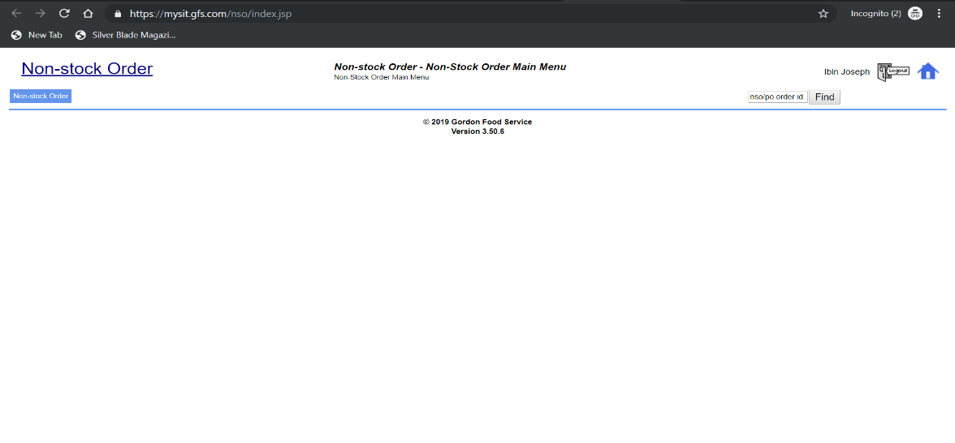

**Operations**

* Create Non-Stock Order.
* Search Non-Stock Order.
* Receive Non-Stock Order.

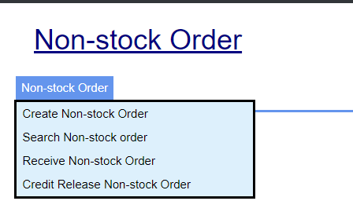

**Create Non-Stock Order**

Creating a Non-Stock Order is just like placing an order. To create an NSO click on Create Non-Stock Order. Then the below screen will open.

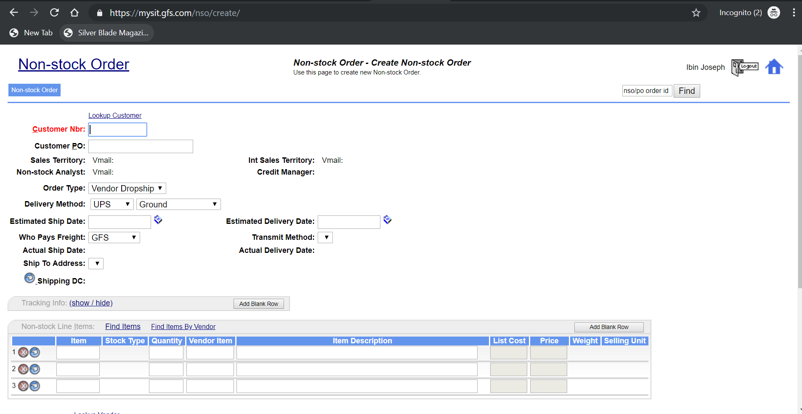

There are some mandatory fields that needs to be filled.

1. **Customer Nbr** – The first mandatory field is Customer Number. Once you input the Customer Number it will automatically fetch some default value such as Customer Name, Order Type etc.

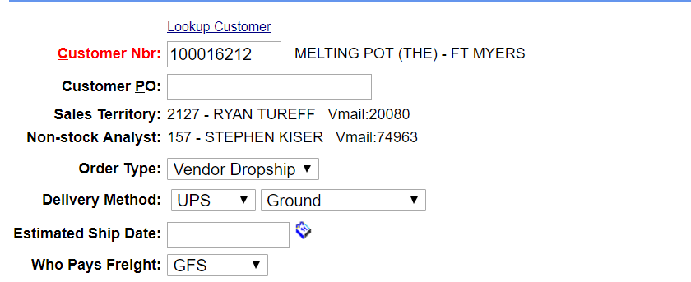

These are some default values for that customer. NSO fetches these details from another application called Customer Aquisition.

1. **Order Type –** The dropdown contains 3 values

* **Vendor Dropship –** The items are directly delivered from the Vendors to the Customers.
* **GFS Warehouse –** The items are delivered from the GFS Warehouse.
* **Bill Only**

1. **Delivery Method –** This specifies the method of delivery dates.
2. **Who pays Freight –** Freight is the expense for the transportation of the items.
3. **Ship to Address -** This is the address of the customer which the items to be delivered.
4. **Adding Items -** Then we need to add the items and quantity. We can identify whether this item is a stock or non-stock by the symbols on the Stock Type field.

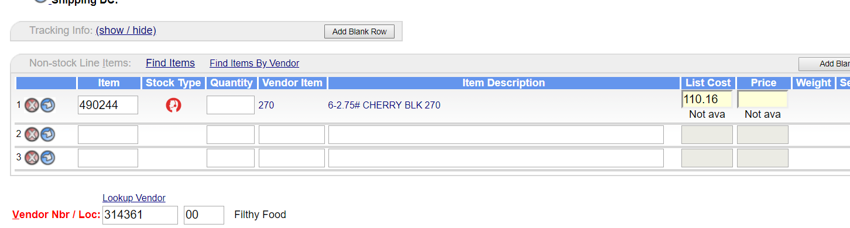

The above added item is a non-stock item. 270 is the vendor item reference and 490244 is the GFS item code. Add quantity then the price is automatically calculated. The Vendor Nbr/Loc Field for that particular item is also automatically populated.

1. **Transmit Method –** It is nothing but a mode of communication that the vendor will know the got an order. There are 3 Transmit methods,

* **Fax**
* **E-Mail**
* **EDI**

This is how a vendor will know about the order like the Customer Id, Shipping Address etc.

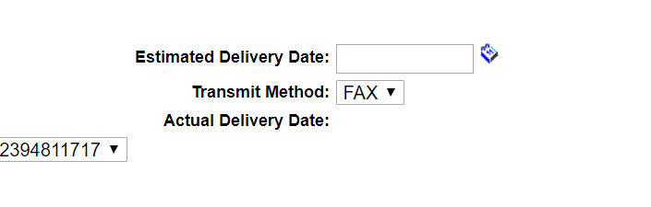

For the above order the method is Fax.

Also we can input some comments using the commend box.

1. **Then click on Create Order button to create the order.**

Then the Non-Stock Order status will change to WAIT, it’s like preview so that you can edit the order.

1. **Then release the order by clicking the Release button.**

Then the WAIT Status will change to WAITING_FAX_TO_VENDOR.

1. **The we need to run some jobs to change the status of the order to the next stage.**

These jobs will run automatically. We can force these jobs to run by the following steps.

1. Go to - <https://wccsit.gfs.com/wcc/ui/Login.html>
2. Click on Quick View 🡪 Search this on name “nso_st_releasepluscreatepo_b”🡪Click Go
3. Select ‘Select and’ Drop Down and select Force Start option.
4. Select the job and click on Go
5. After a refresh we can the status is changed.
6. **The NSO status will changed to** ON_ORDER_FROM_VENDOR after running the jobs. It means a Fax is sent to the Vendor regarding the Order.
7. **The Vendor got the order so a GFS Purchase Order is automatically generate and attach to this NSO.**

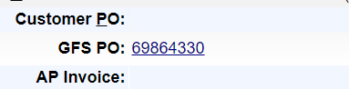

1. **Click on PO number to view the Purchase Order.**